Greg’s List

Technical Design Document

# 

Table of Contents

Team Members 3

Product Idea 4

Product Features 4

Intended User Groups 4

User Profiles 4

Software Requirements 5

Use Case Diagram 6

Physical Database Model 6

Database Model Explanation 7

Software Architecture Diagram 7

Usability Test Outline 8

Paper Prototypes 9

Usability Report 25

Task Analysis 27

Object/Action Analysis and Matrix 28

Software Lexicon 28

# 

# Team Members

Carter Dewey Chief Website Developer

Amanda Doyle Head Android Developer

Bobby Santoski Lead GUI Design

Greg Walters Database Manager

Morgan Winslow Database Specialist

# Product Idea

Our team will create an SMU-specific marketplace to exchange goods like textbooks, bikes,

dorm furniture, and arrange meetings for studying, etc.

# Product Features

-Contact and communicate with buyers/sellers

-Provide buyer/seller feedback to rate trustworthiness

-Search listings

-Post a listing

-Delete your listing

-Report abuse

-Listing categories

# Intended User Groups

**Students:** SMU students will be the primary users. They will post the listings, buy and sell

to each other, and provide the vast majority of the site's content.

**Administrators** will respond to abuse reports.

## User Profiles

**Carlos Ramsey**

**Age:** 18

**Career:** College Student at Southern Methodist University

**Knowledge Dimensions:** Has a very good understanding about how to use a computer and

navigate the internet.

**Experience:** Has used internet auction sites such as eBay and has bought many products online.

**Interest in GregsList:** Perfect potential user for GregsList. As a Freshman coming into SMU he

has a need for things such as furniture and books. In addition to this he has used the Internet to

search for products online before which makes him likely to seek out GregList.

**Courtney Wolfe**

**Age:** 22

**Career:** College Student at the University of Texas

**Knowledge** Dimensions: Has a very good understanding about how to use a computer and

navigate the internet.

**Experience:** Has used the internet to purchase things before on sites such as Amazon.

**Interest in GregsList:** Would be a potential user of GregsList, but does not attend SMU and

therefore would not be able to access the website.

**Ella Matthews**

**Age:** 36

**Career:** Professor at Southern Methodist University

**Knowledge Dimensions:** Has a basic idea of how to use a computer and navigate the internet

**Experience:** Has used eBay to buy and sell products.

**Interest in GregsList:** Potential user for GregsList. Could use the website to sell school supplies

from previous semesters she has no use for anymore such as textbooks and calculators.

**Nathan Goodwin**

**Age:** 53

**Career:** Professor at the University of Texas

**Knowledge Dimensions:** Can only use the internet for the most basic tasks such as checking

email.

**Experience:** Has never bought or sold anything online.

**Interest in GregsList:** Not a potential user for GregList and would not be able to access the

website.

# Software Requirements

* The software will limit access to users who have an SMU email only
* The software will require a valid email (SMU) and password to enter the site
* The software will add people to the database via a signup page if they are new users
* The software will redirect users to the home page after signing in/signing up
* The software will allow users to access their account page to edit personal information, listings, and watched listings
* The software will allow users to create a listing
* The software will update what fields appear to create a listing depending on the category and subcategory selected
  + Fields such as Title, Category, Subcategory, and Description will be standard
* The software will allow users to upload pictures for their listing
* The software will allow users to search for listings
* The software will allow users to search for listings based on different criteria such as category, subcategory, and title
* The software will display the three most recent listings for each category on the home page
* The software will allow a user to respond to a listing via email. The person who listed the item may also leave other contact information if desired
* The software will allow the user to logout of the website

# Use Case Diagram

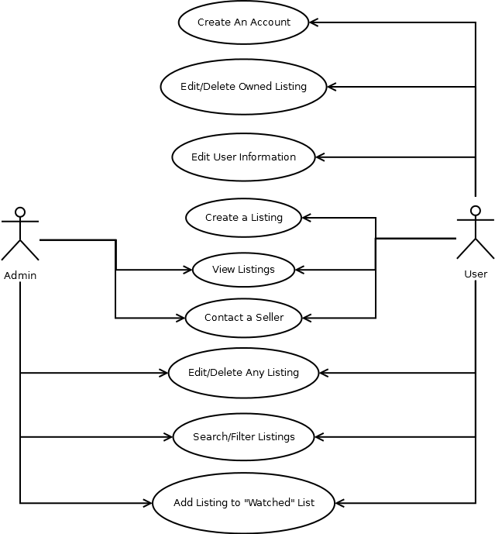

# Physical Database Model

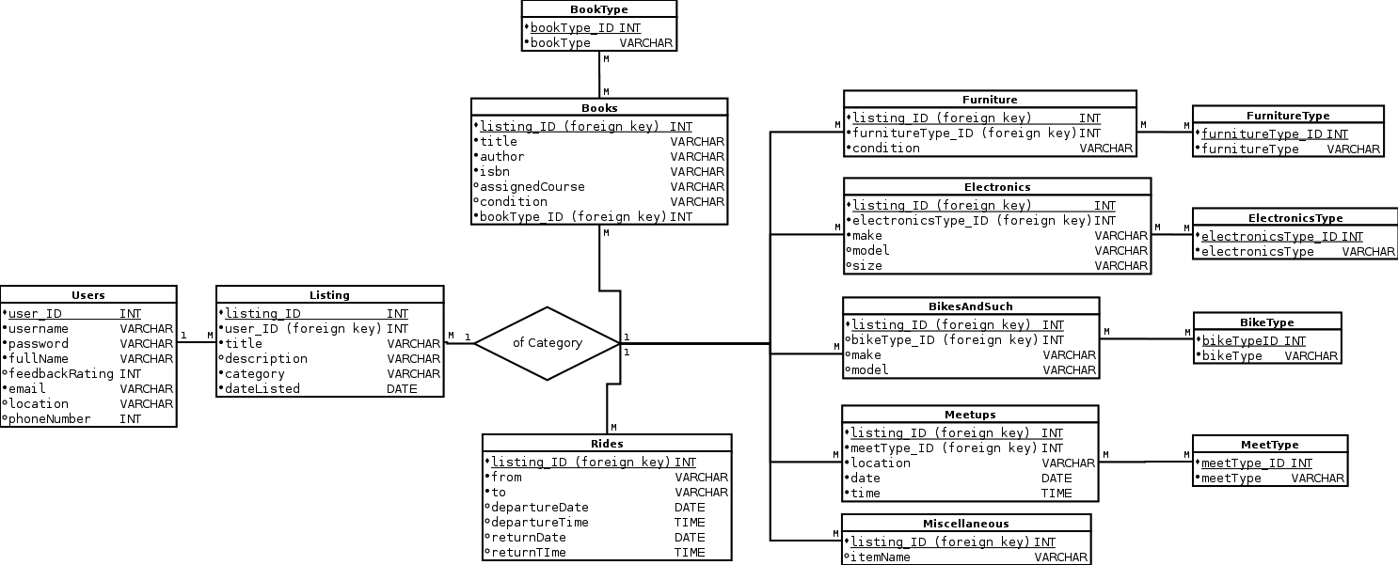

For easier visibility please visit this link: <http://lyle.smu.edu/~adoyle/3345/DatabaseModel4.png>

# Database Model Explanation

The two main features of the GregsList service are the users and the listings. The Users table

stores all the user’s account and contact information. The Listings table contains all the website’s

listings of every type, and each listing refers to the user who created it. In addition to storing basic

listing information, it also links to tables with additional information. Each category table holds more

specific information particular to the listing’s category and refers to the listing’s ID number. By basic

queries, we will be able to select listings by user, by category, or by search criteria, and provide the

lister’s contact information with each listing.

# Software Architecture Diagram

WAITING

# Usability Test Outline

**Facilitator – Carter Dewey**

**Computer – Bobby Santoski**

**Log Keeper – Amanda Doyle**

**Test Purpose:** To find out where the system is hard to understand or inconvenient. We want to find

the flaws in the system so we can rectify those issues and improve overall user experience.

**Users:**

* Professor Raley
* Sarah Lynn Woodruff
* Kevin Donahoo
* Nathan Hillis

**Usability Factors Focus:**

* Fit for use
* Ease of learning
* Subjective satisfaction

**Types of Tests:**

* Think aloud
* Cooperation

**Questions:**

1. Could you sign up for Greg’s List?

2. Can you log into Greg’s List?

3. Were you able to clearly fix any log in/ sign up errors/ were the error messages clear?

4. You are looking to furnish your new apartment can you browse the furniture listings?

5. Oh no! You dropped your phone and shattered the screen can you find a used phone to buy?

6. You found the phone you want to buy can you find a way to contact the seller.

7. Unfortunately the new phone you bought was on a different network and you were forced to get a

new phone number, can you update your profile to reflect your new number?

8. You are a bit short on cash for the upcoming music festival and you want to sell you old laptop to

raise some cash for the festival can you create your own listing?

9. You set up a sick photo studio in your spacious McElvaney dorm and take some pretty sweet

photos of your old laptop can you add them while creating your listing?

10. You realized that instead of asking $200 for your laptop you asked for $2000 can you edit your

listing to fix that?

**Measurement:**

* Task Time
* Score for Understanding
* Opinion Poll
* Identifying issues by type and severity

# Paper Prototypes

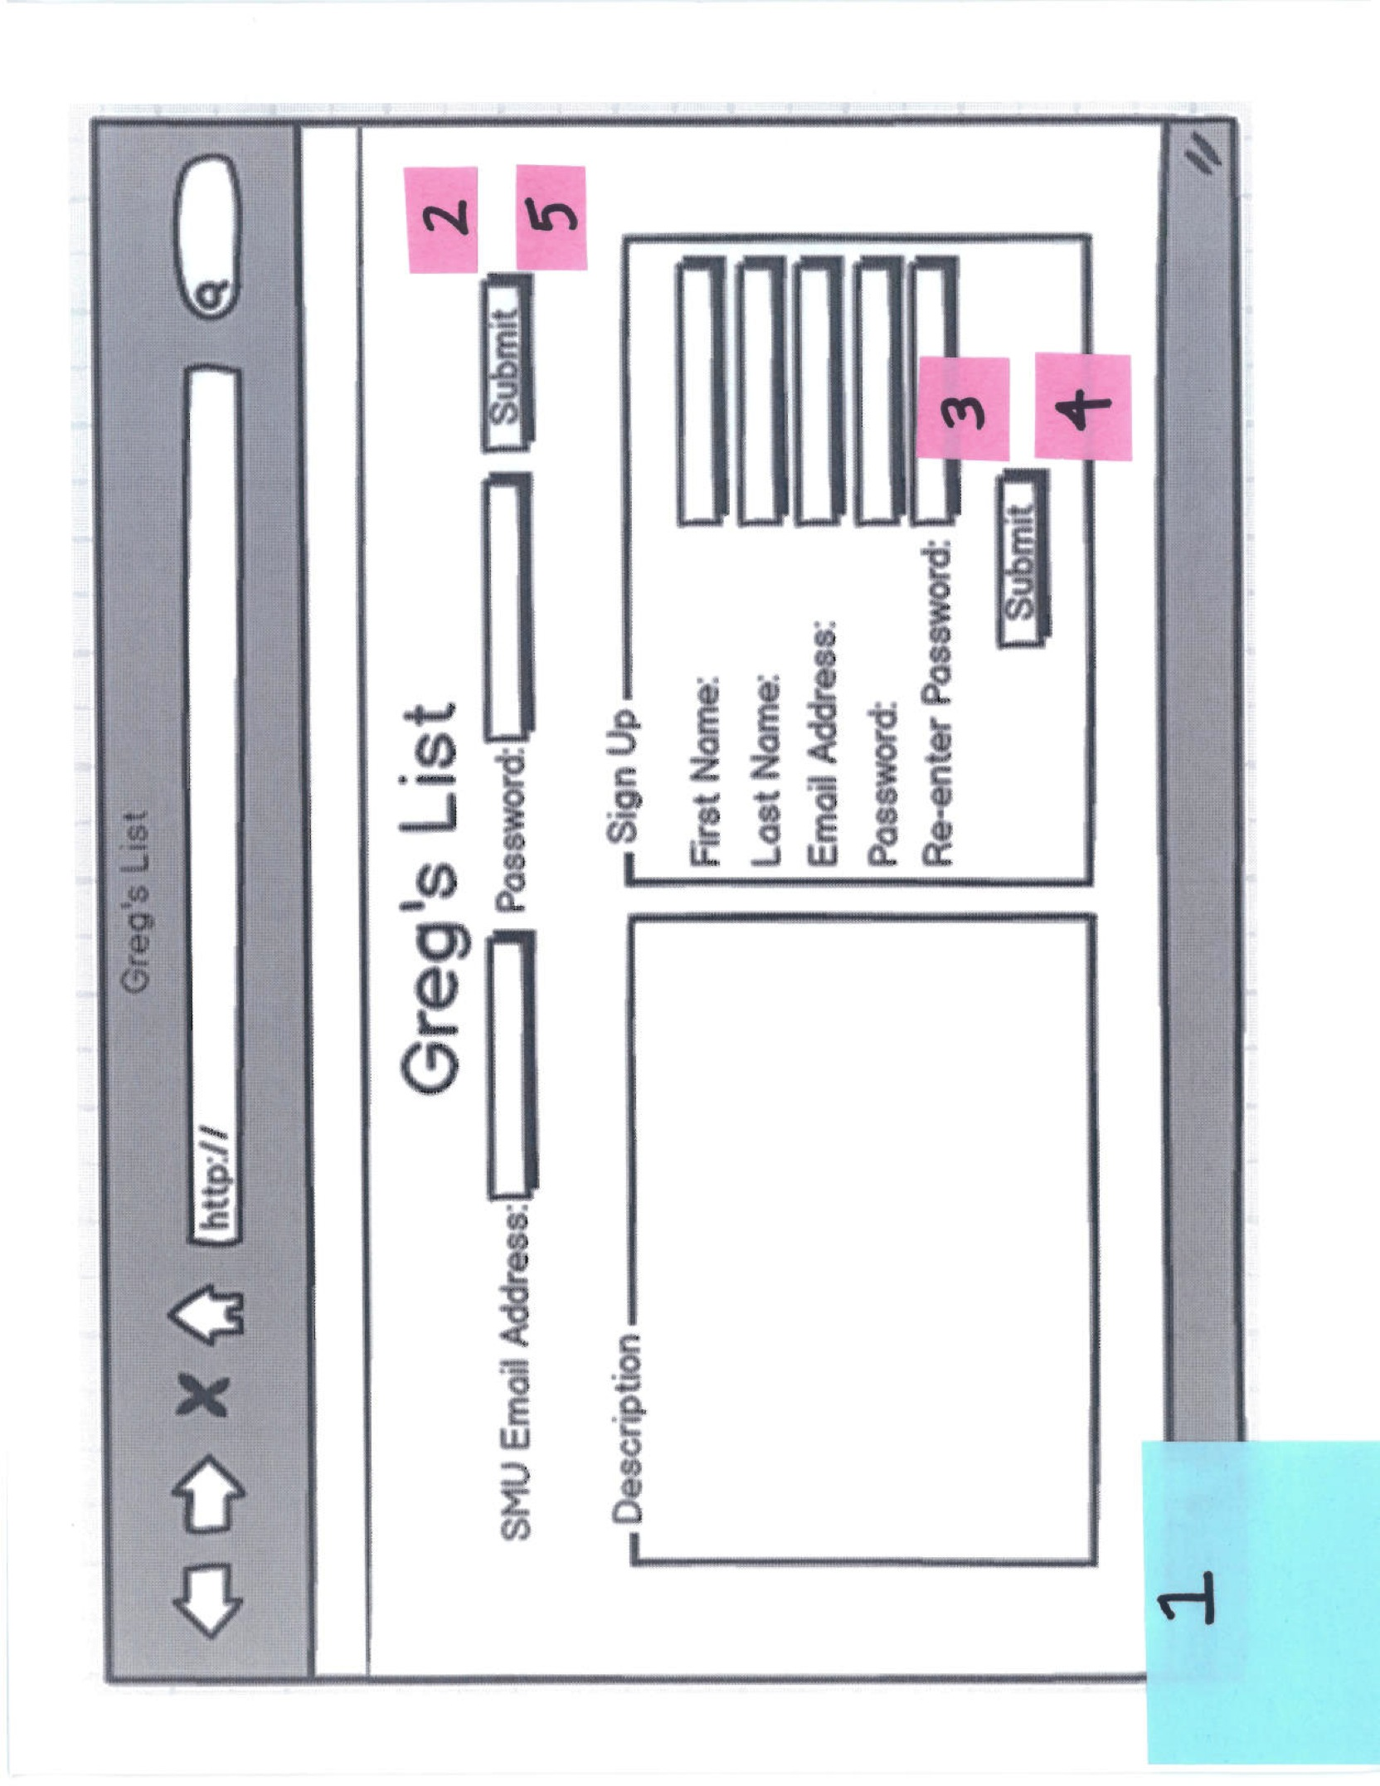

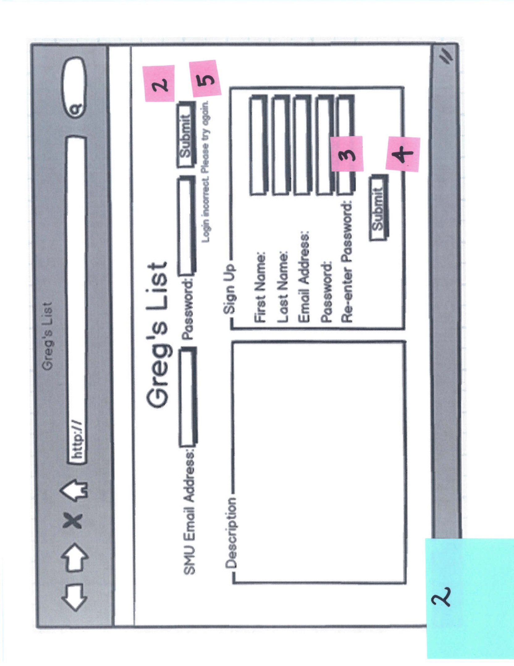

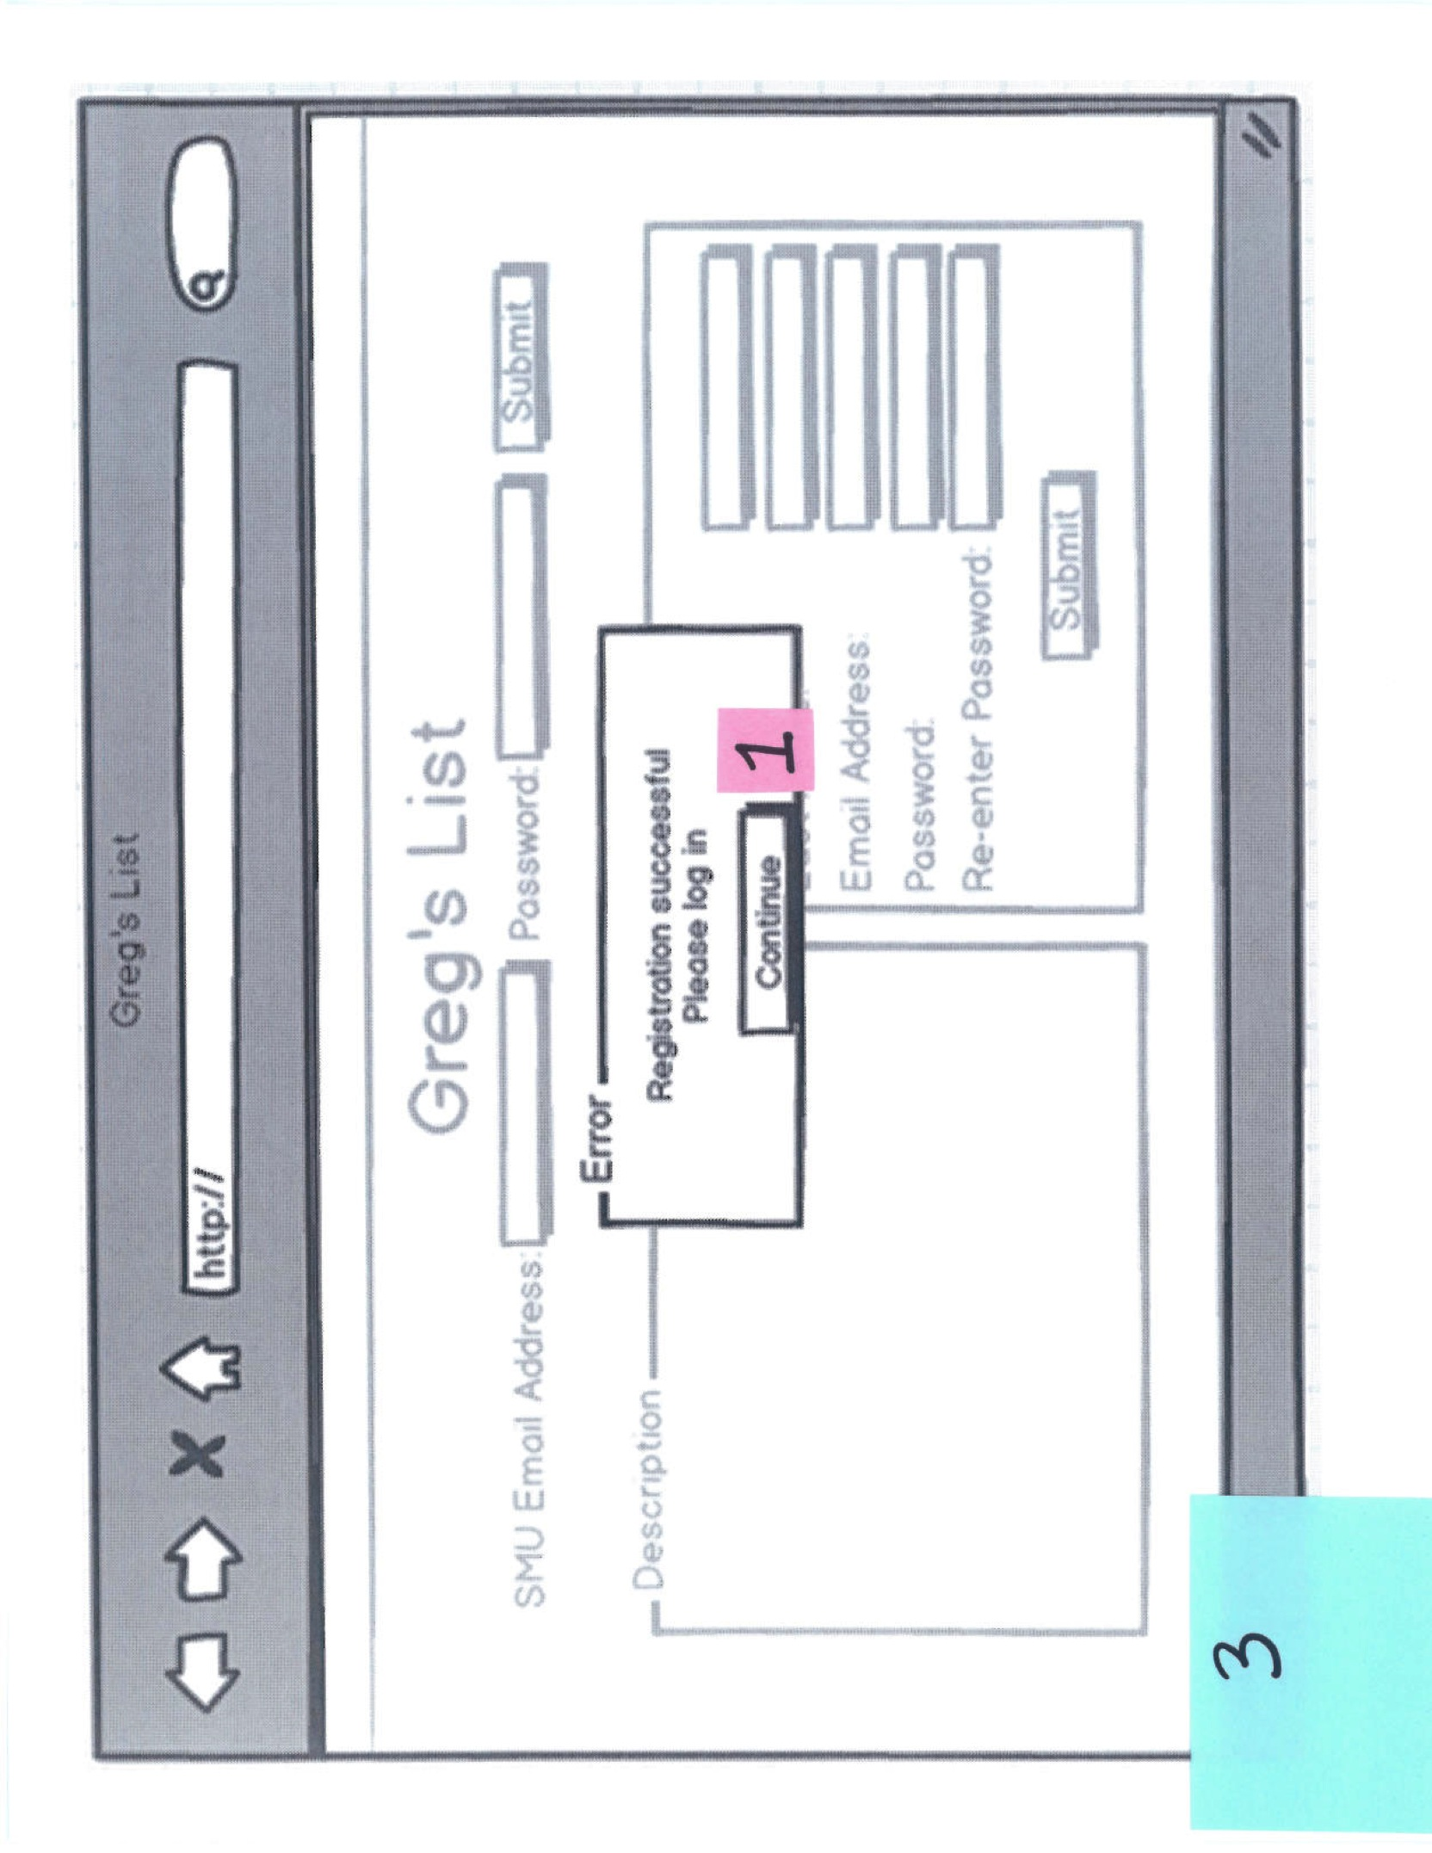

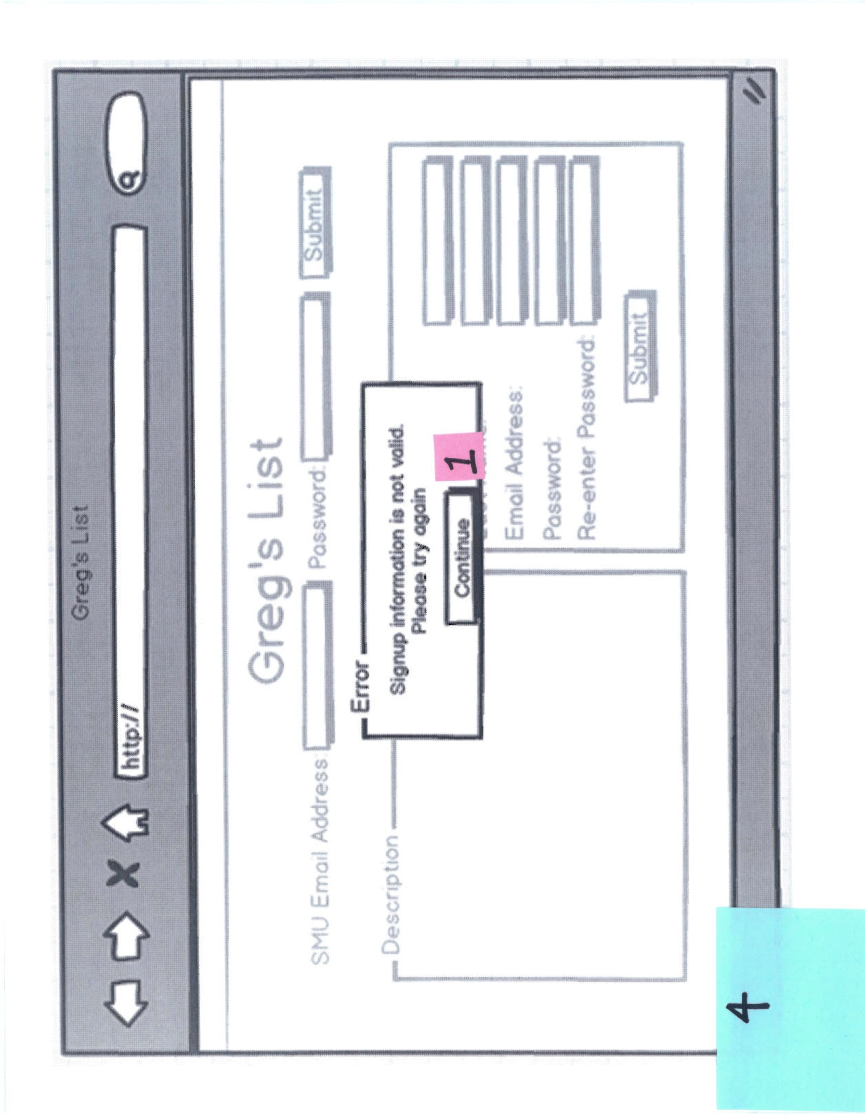

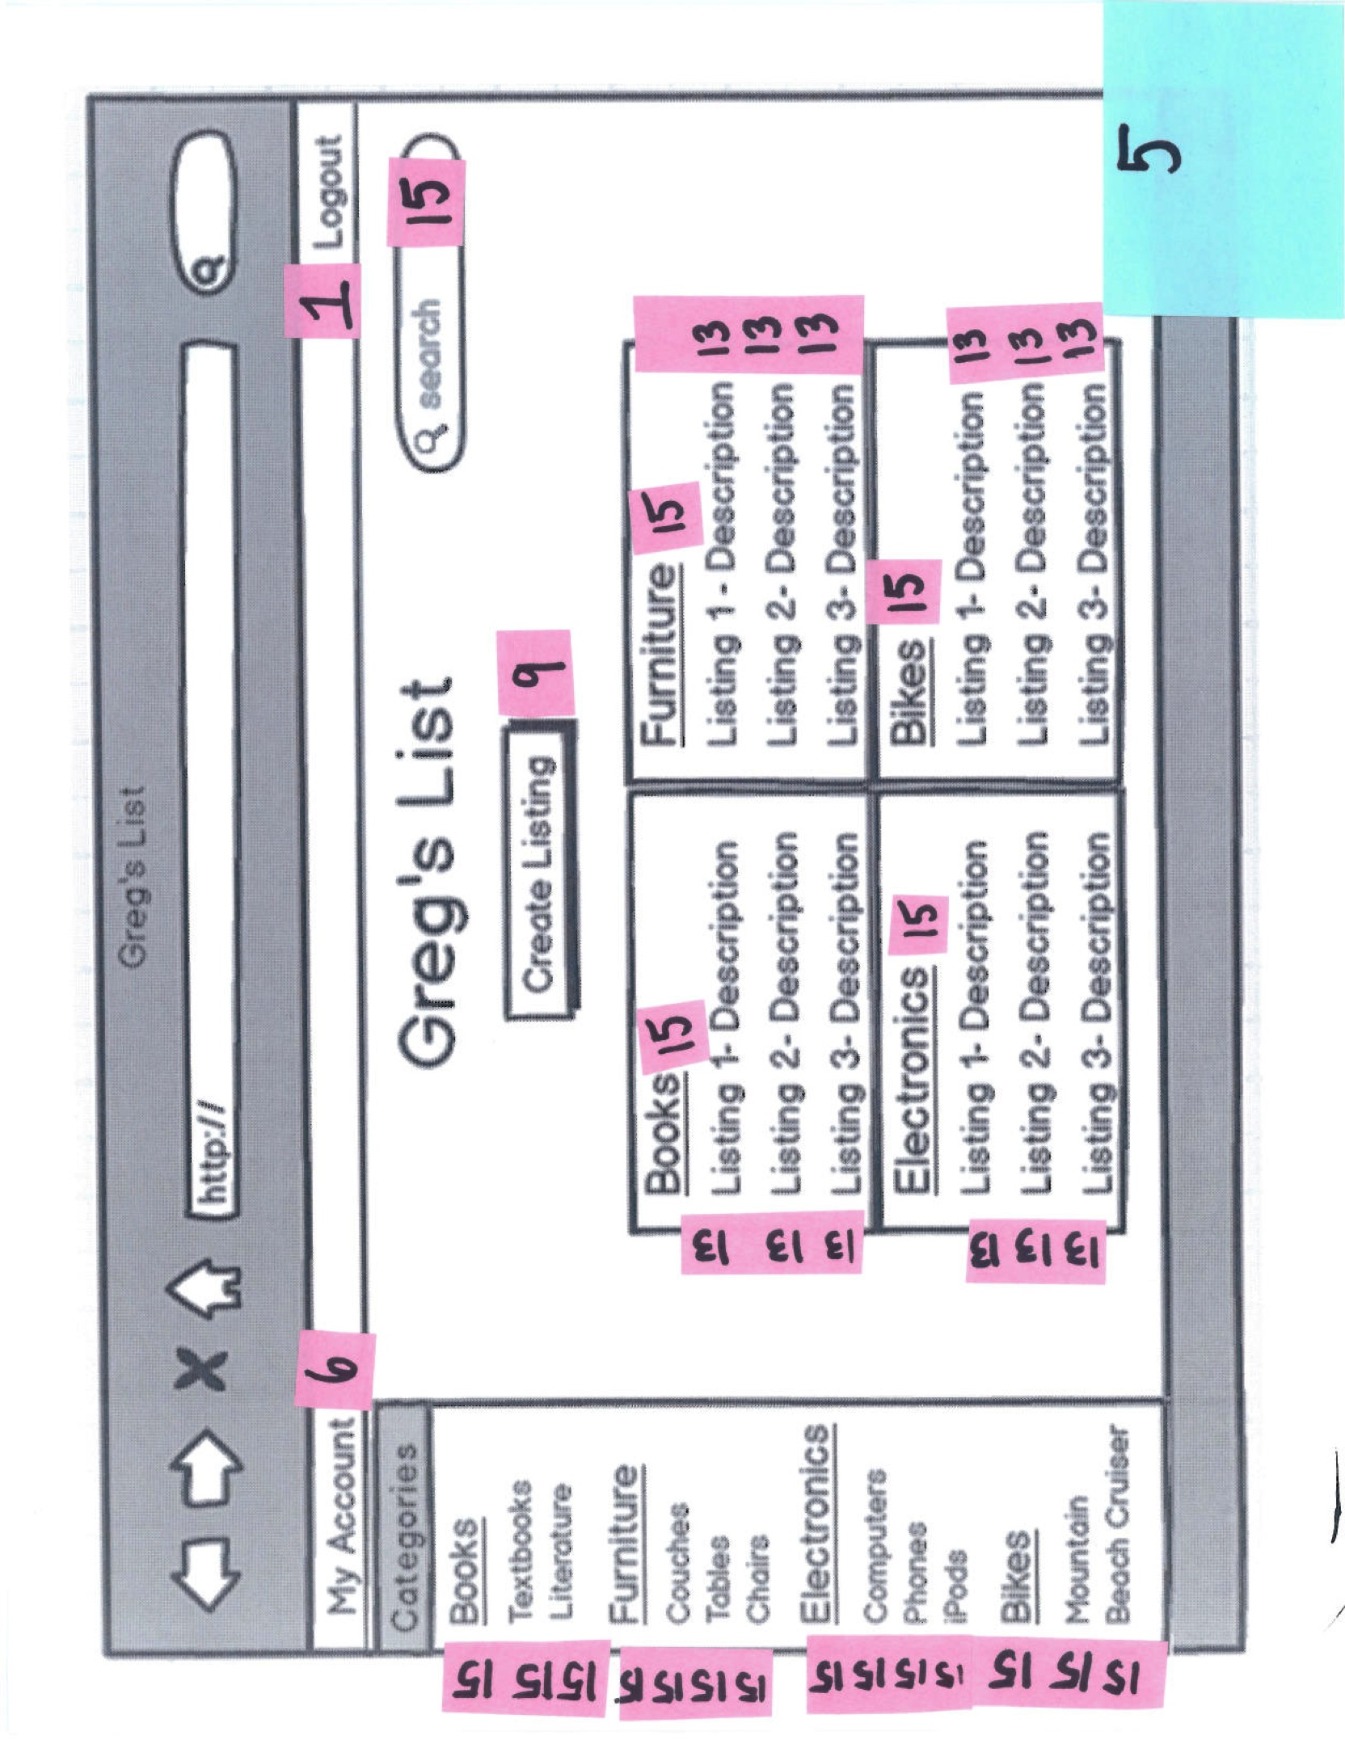 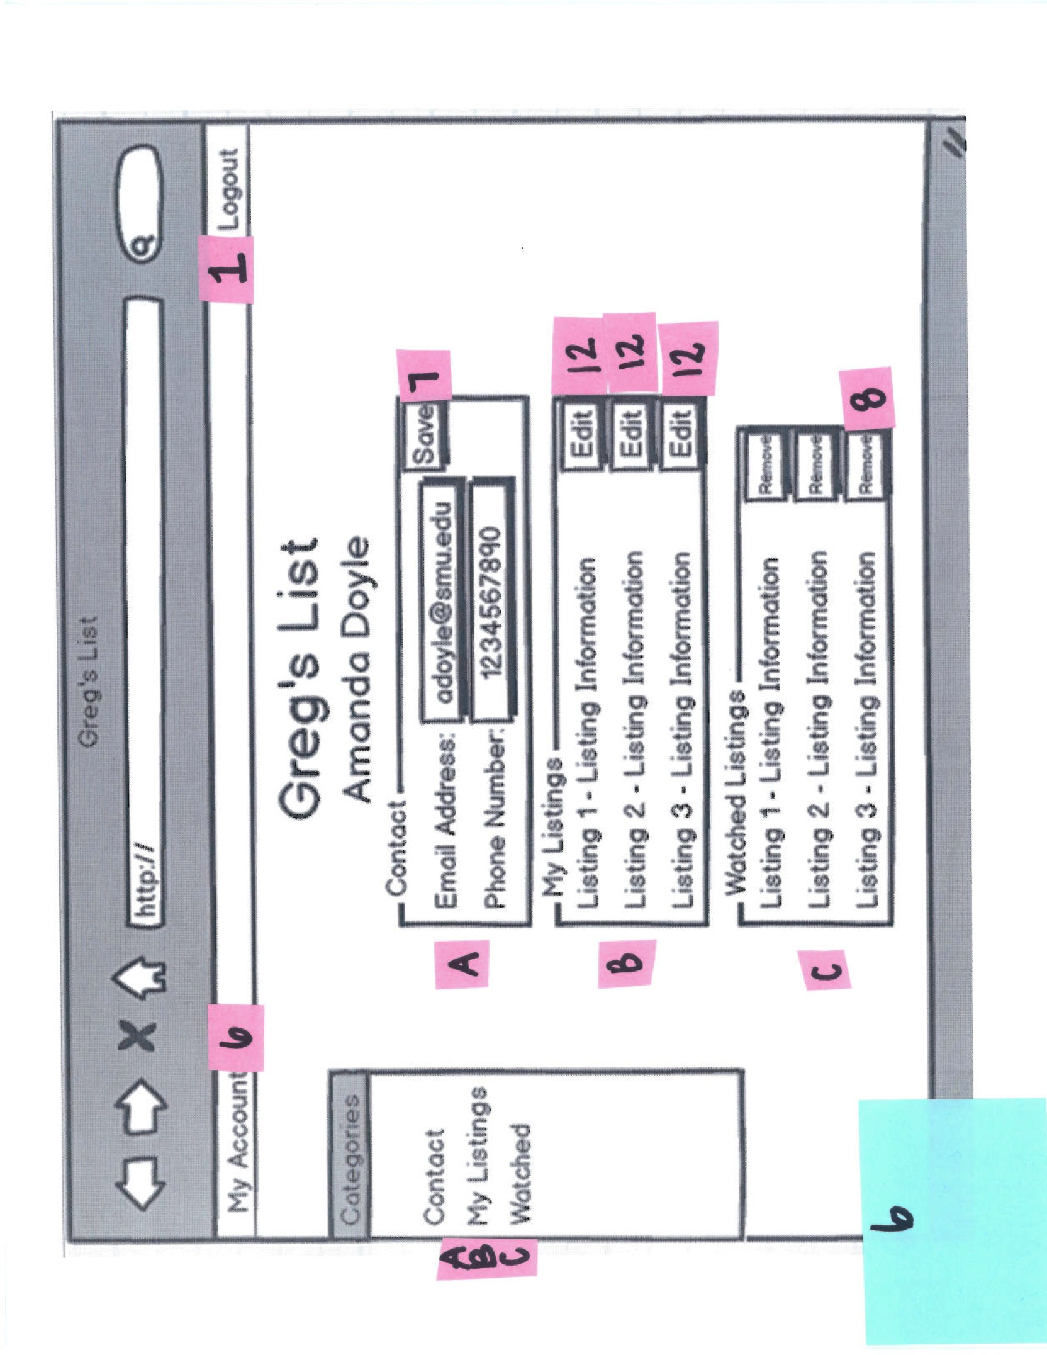 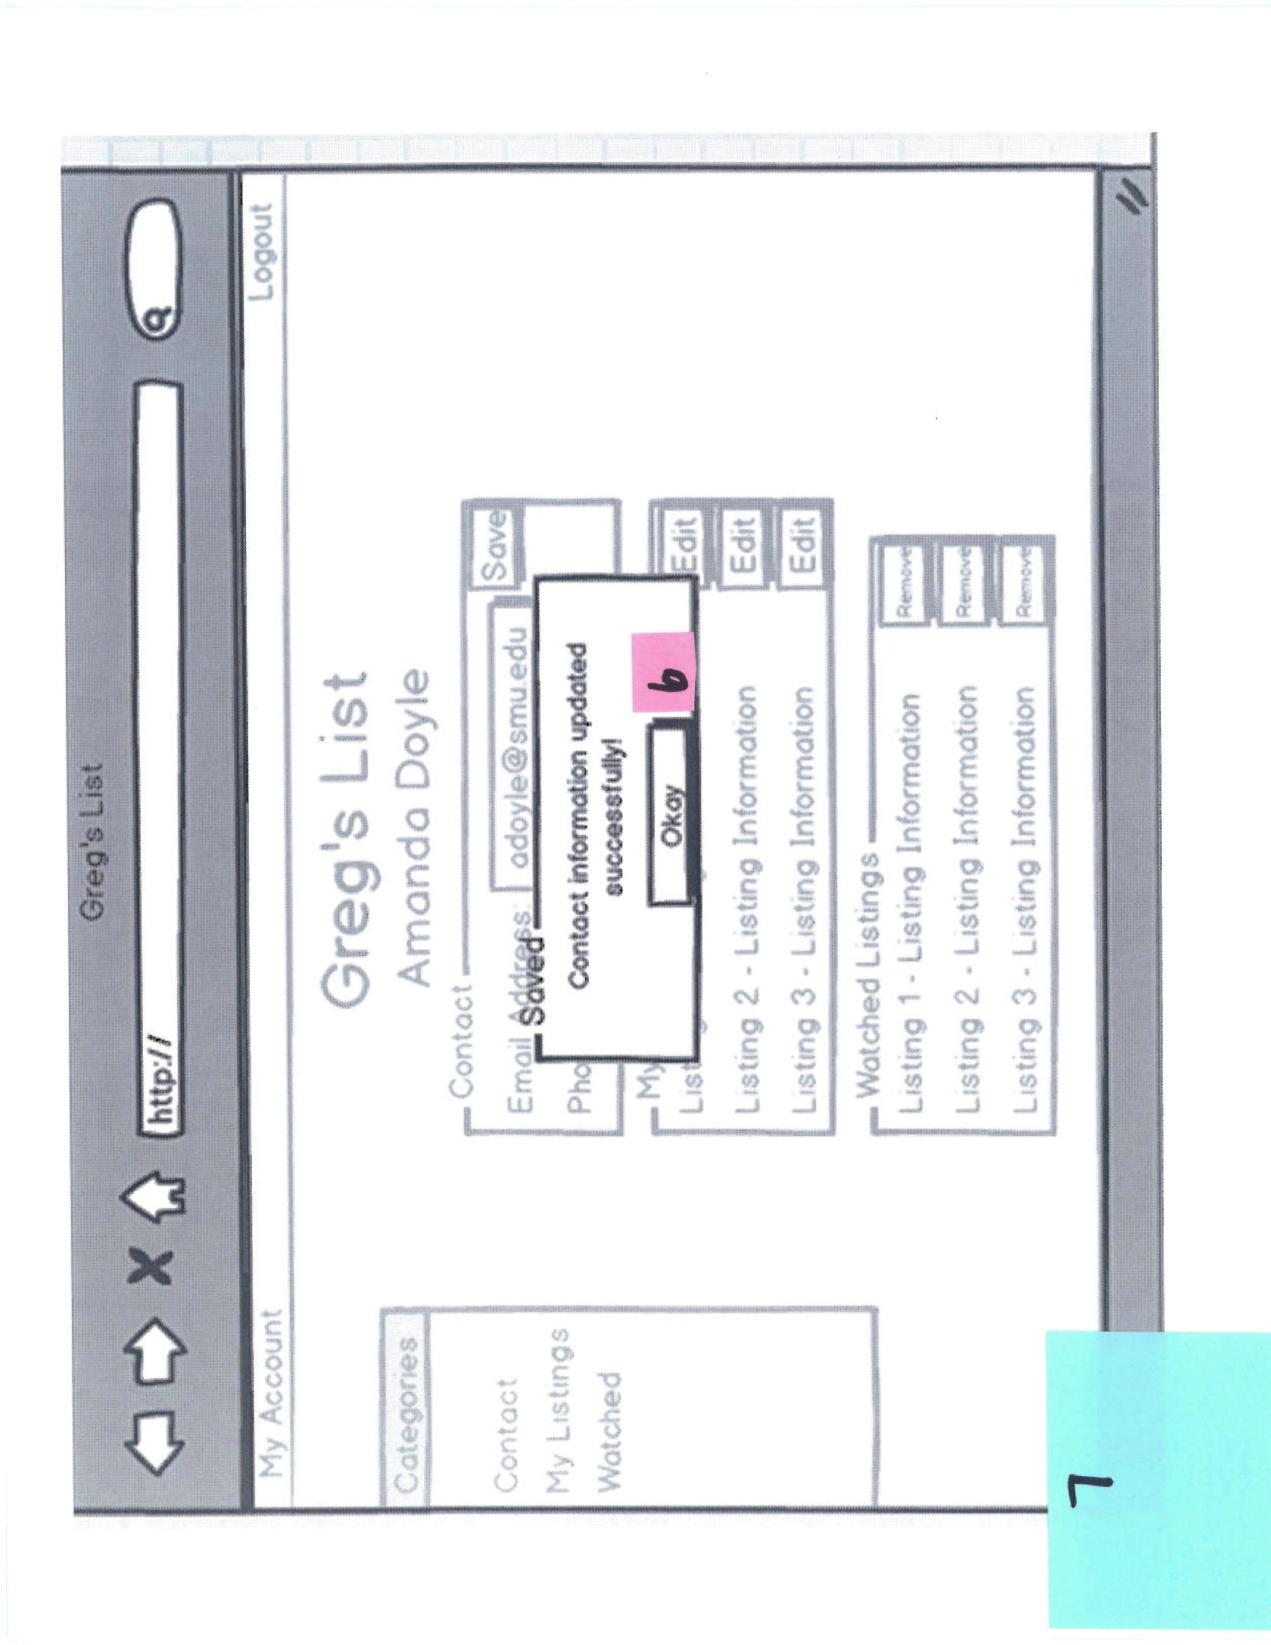 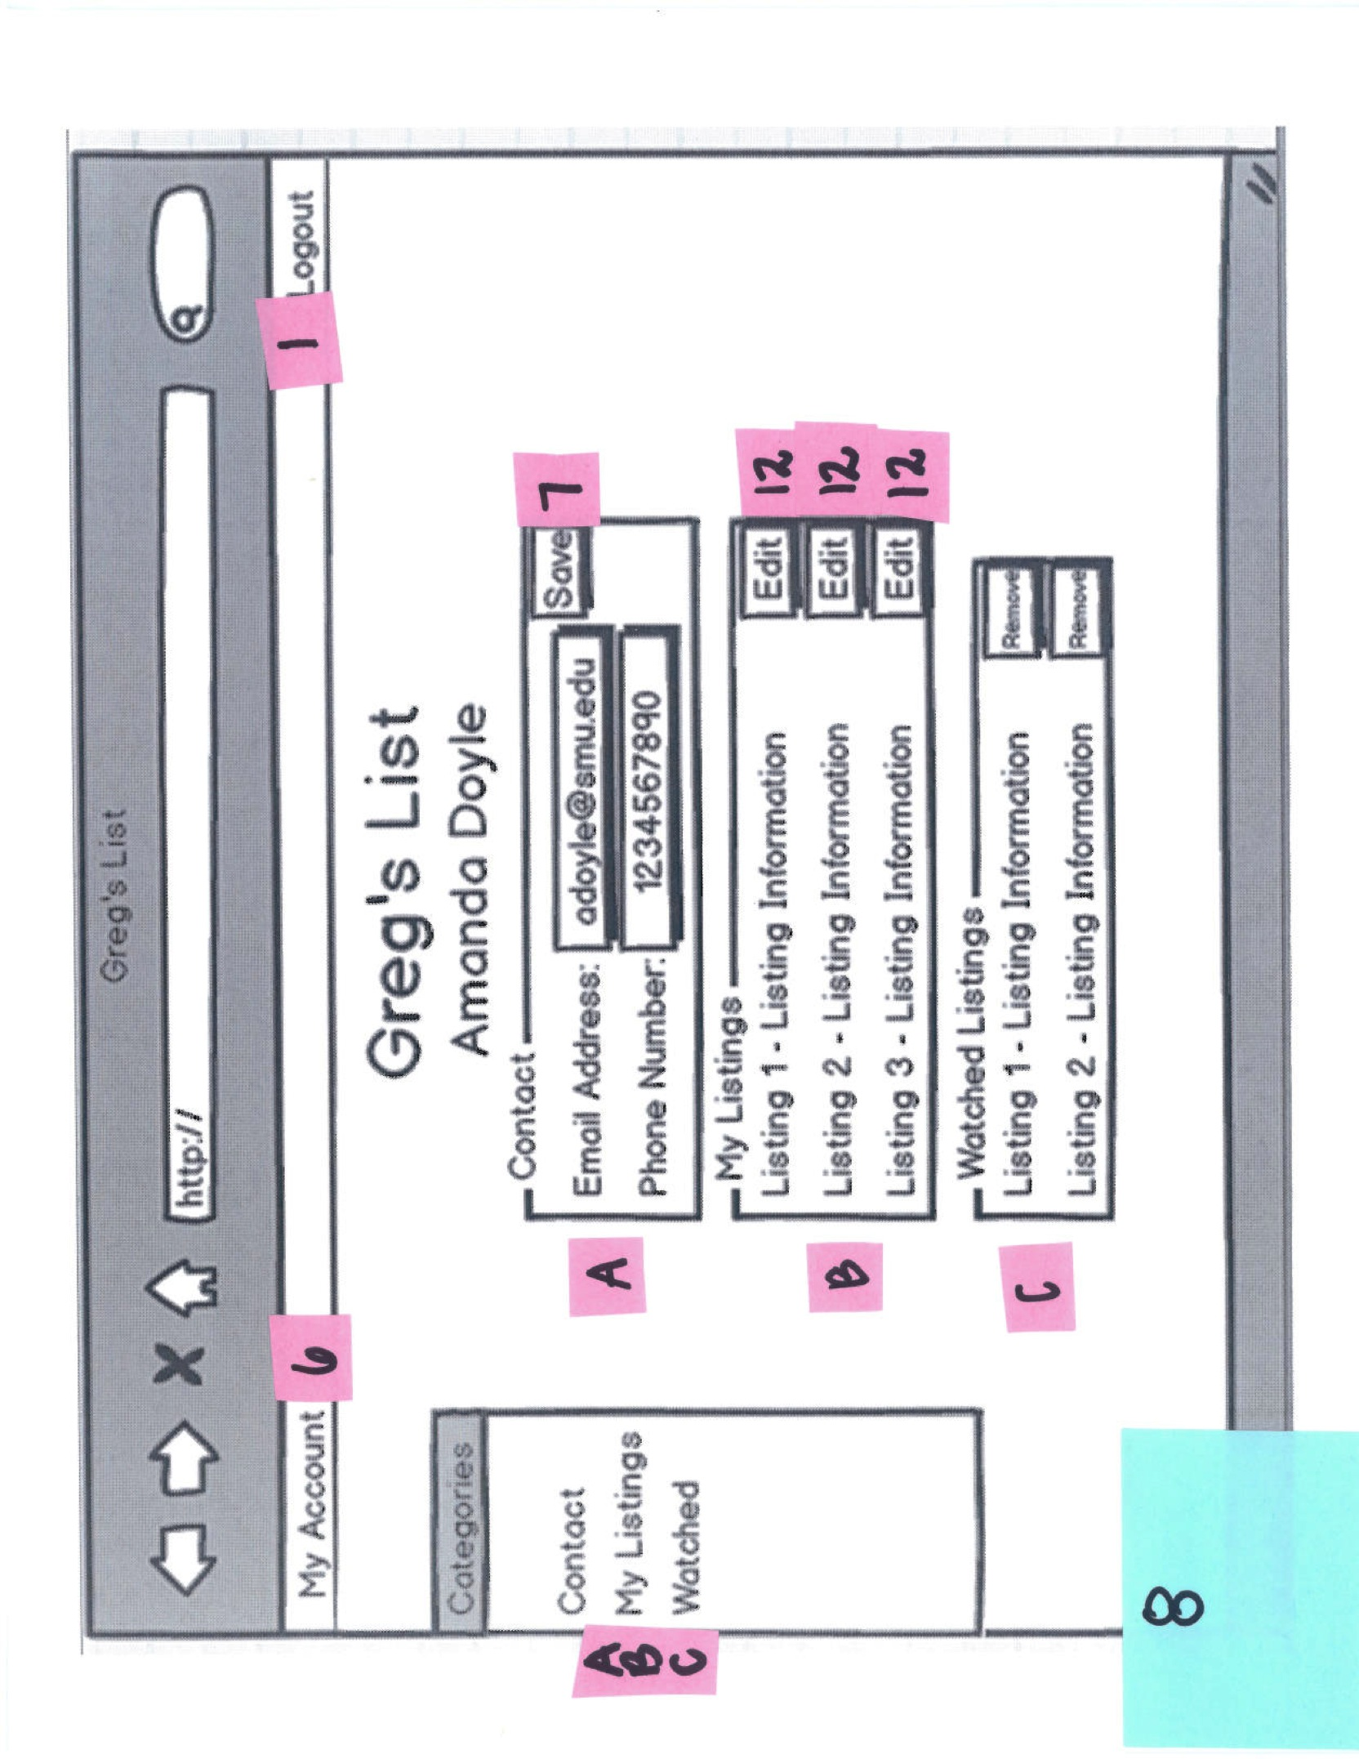 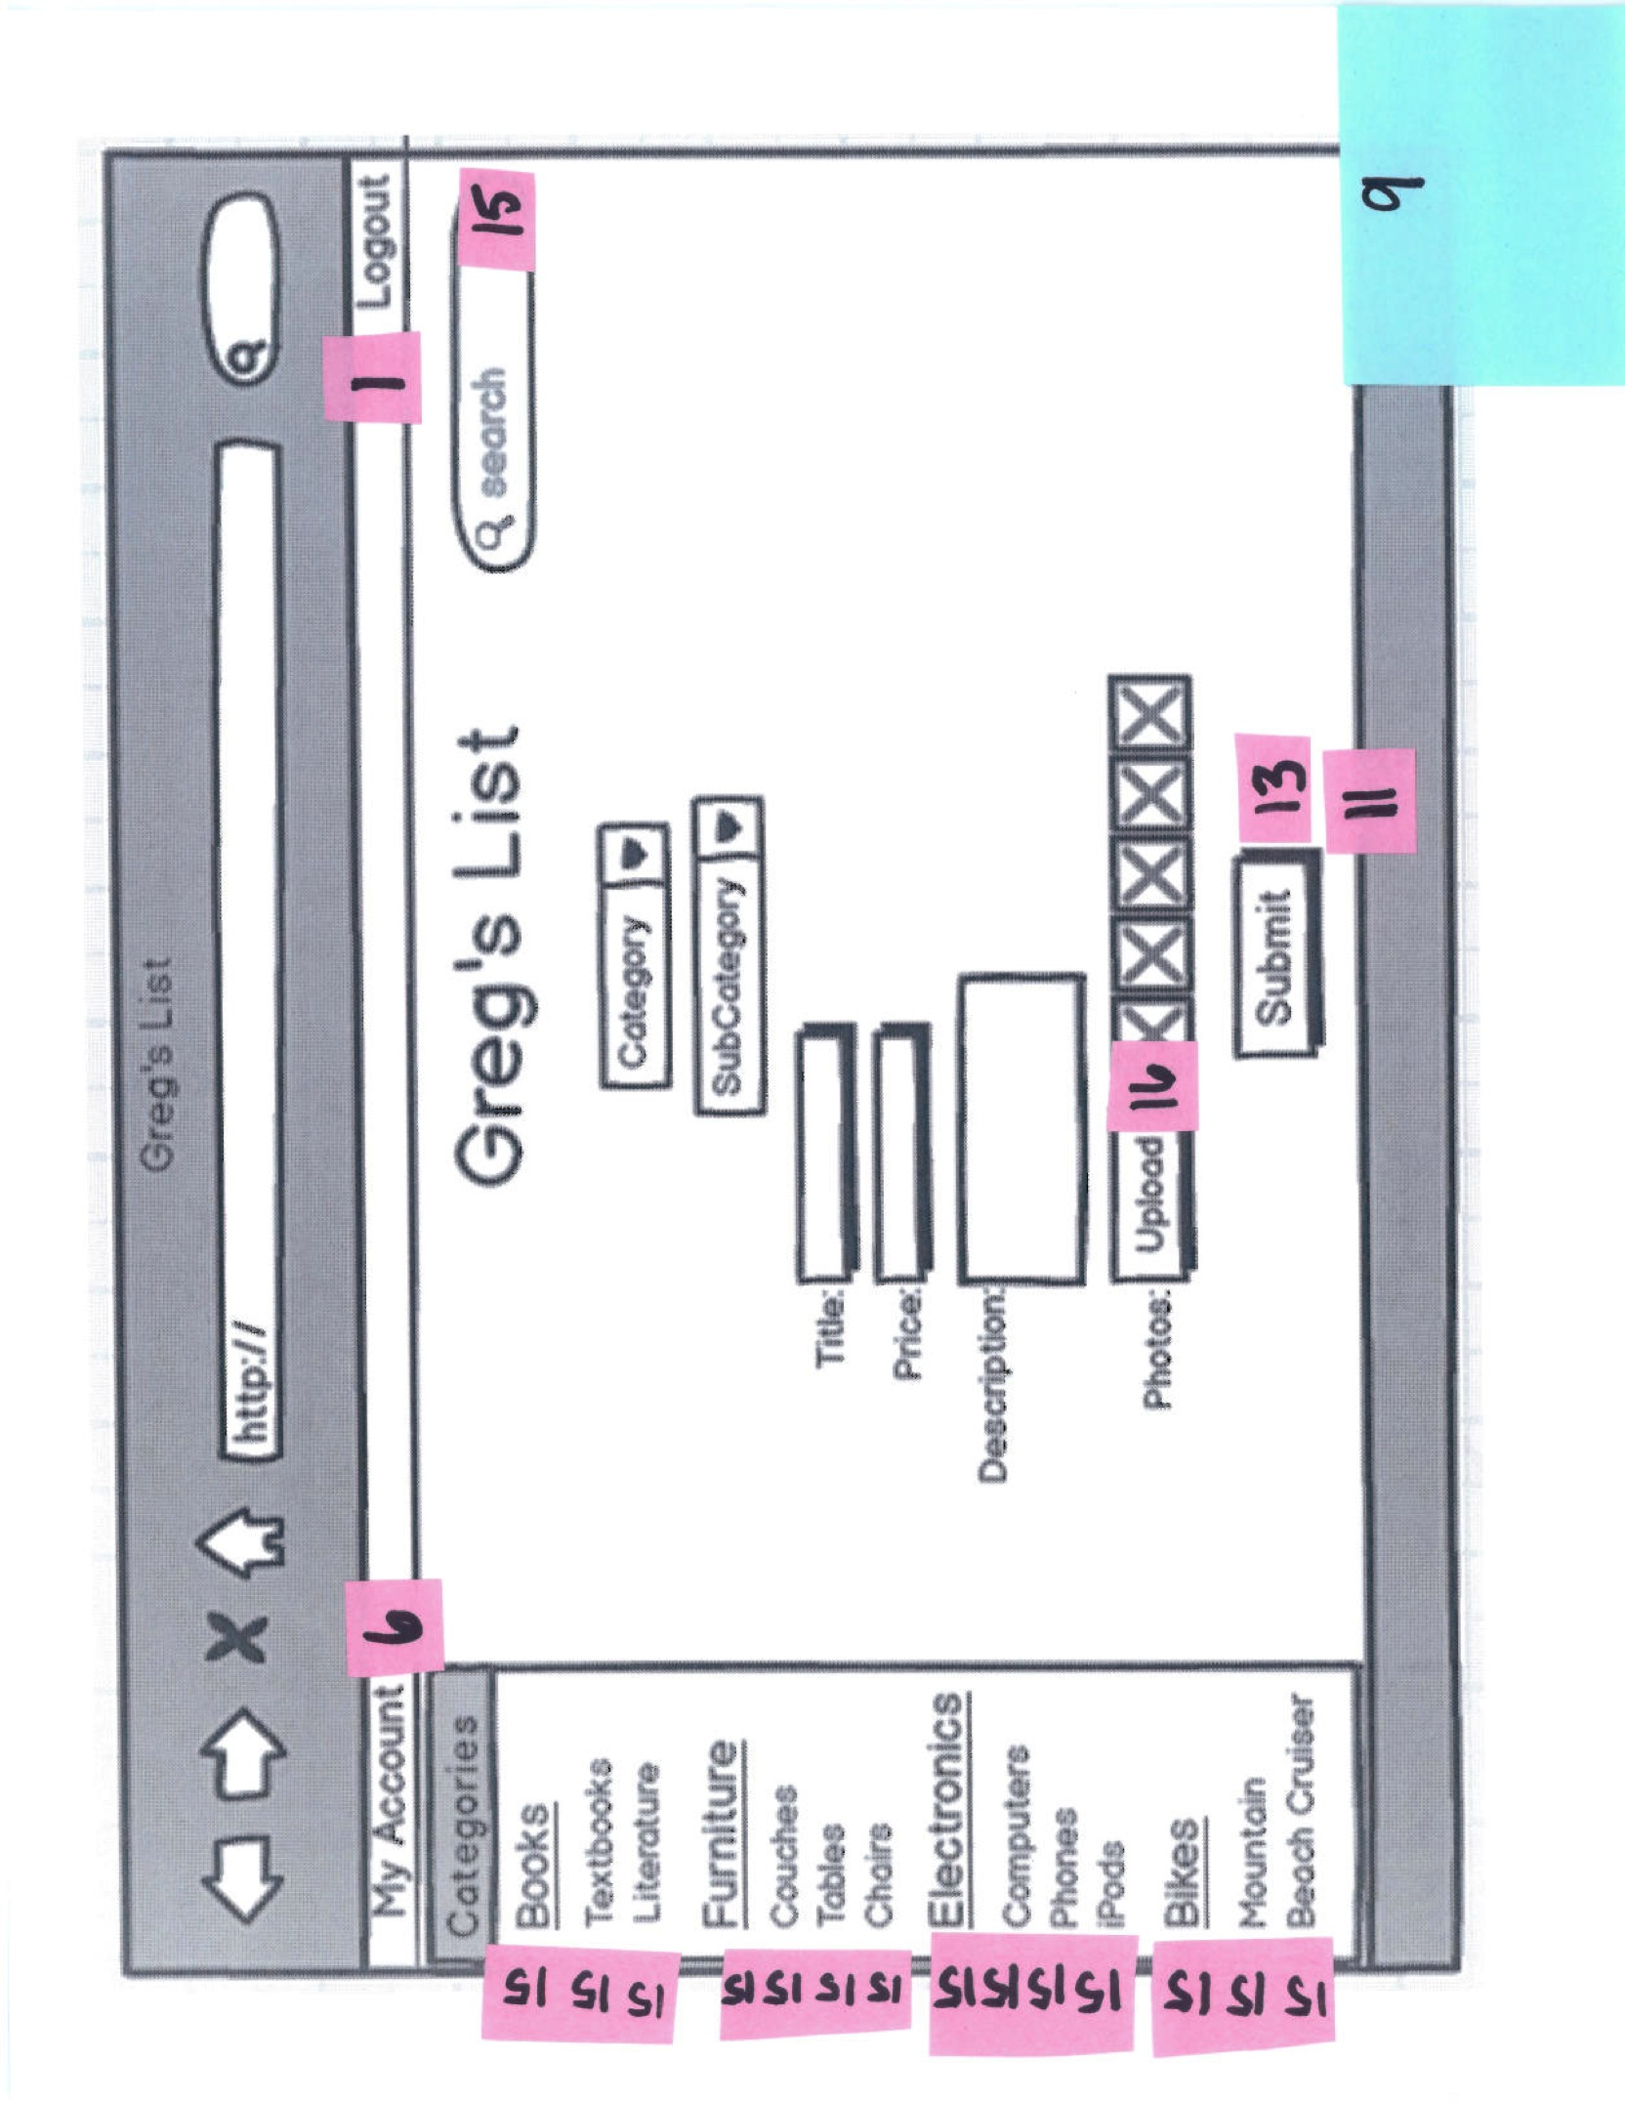 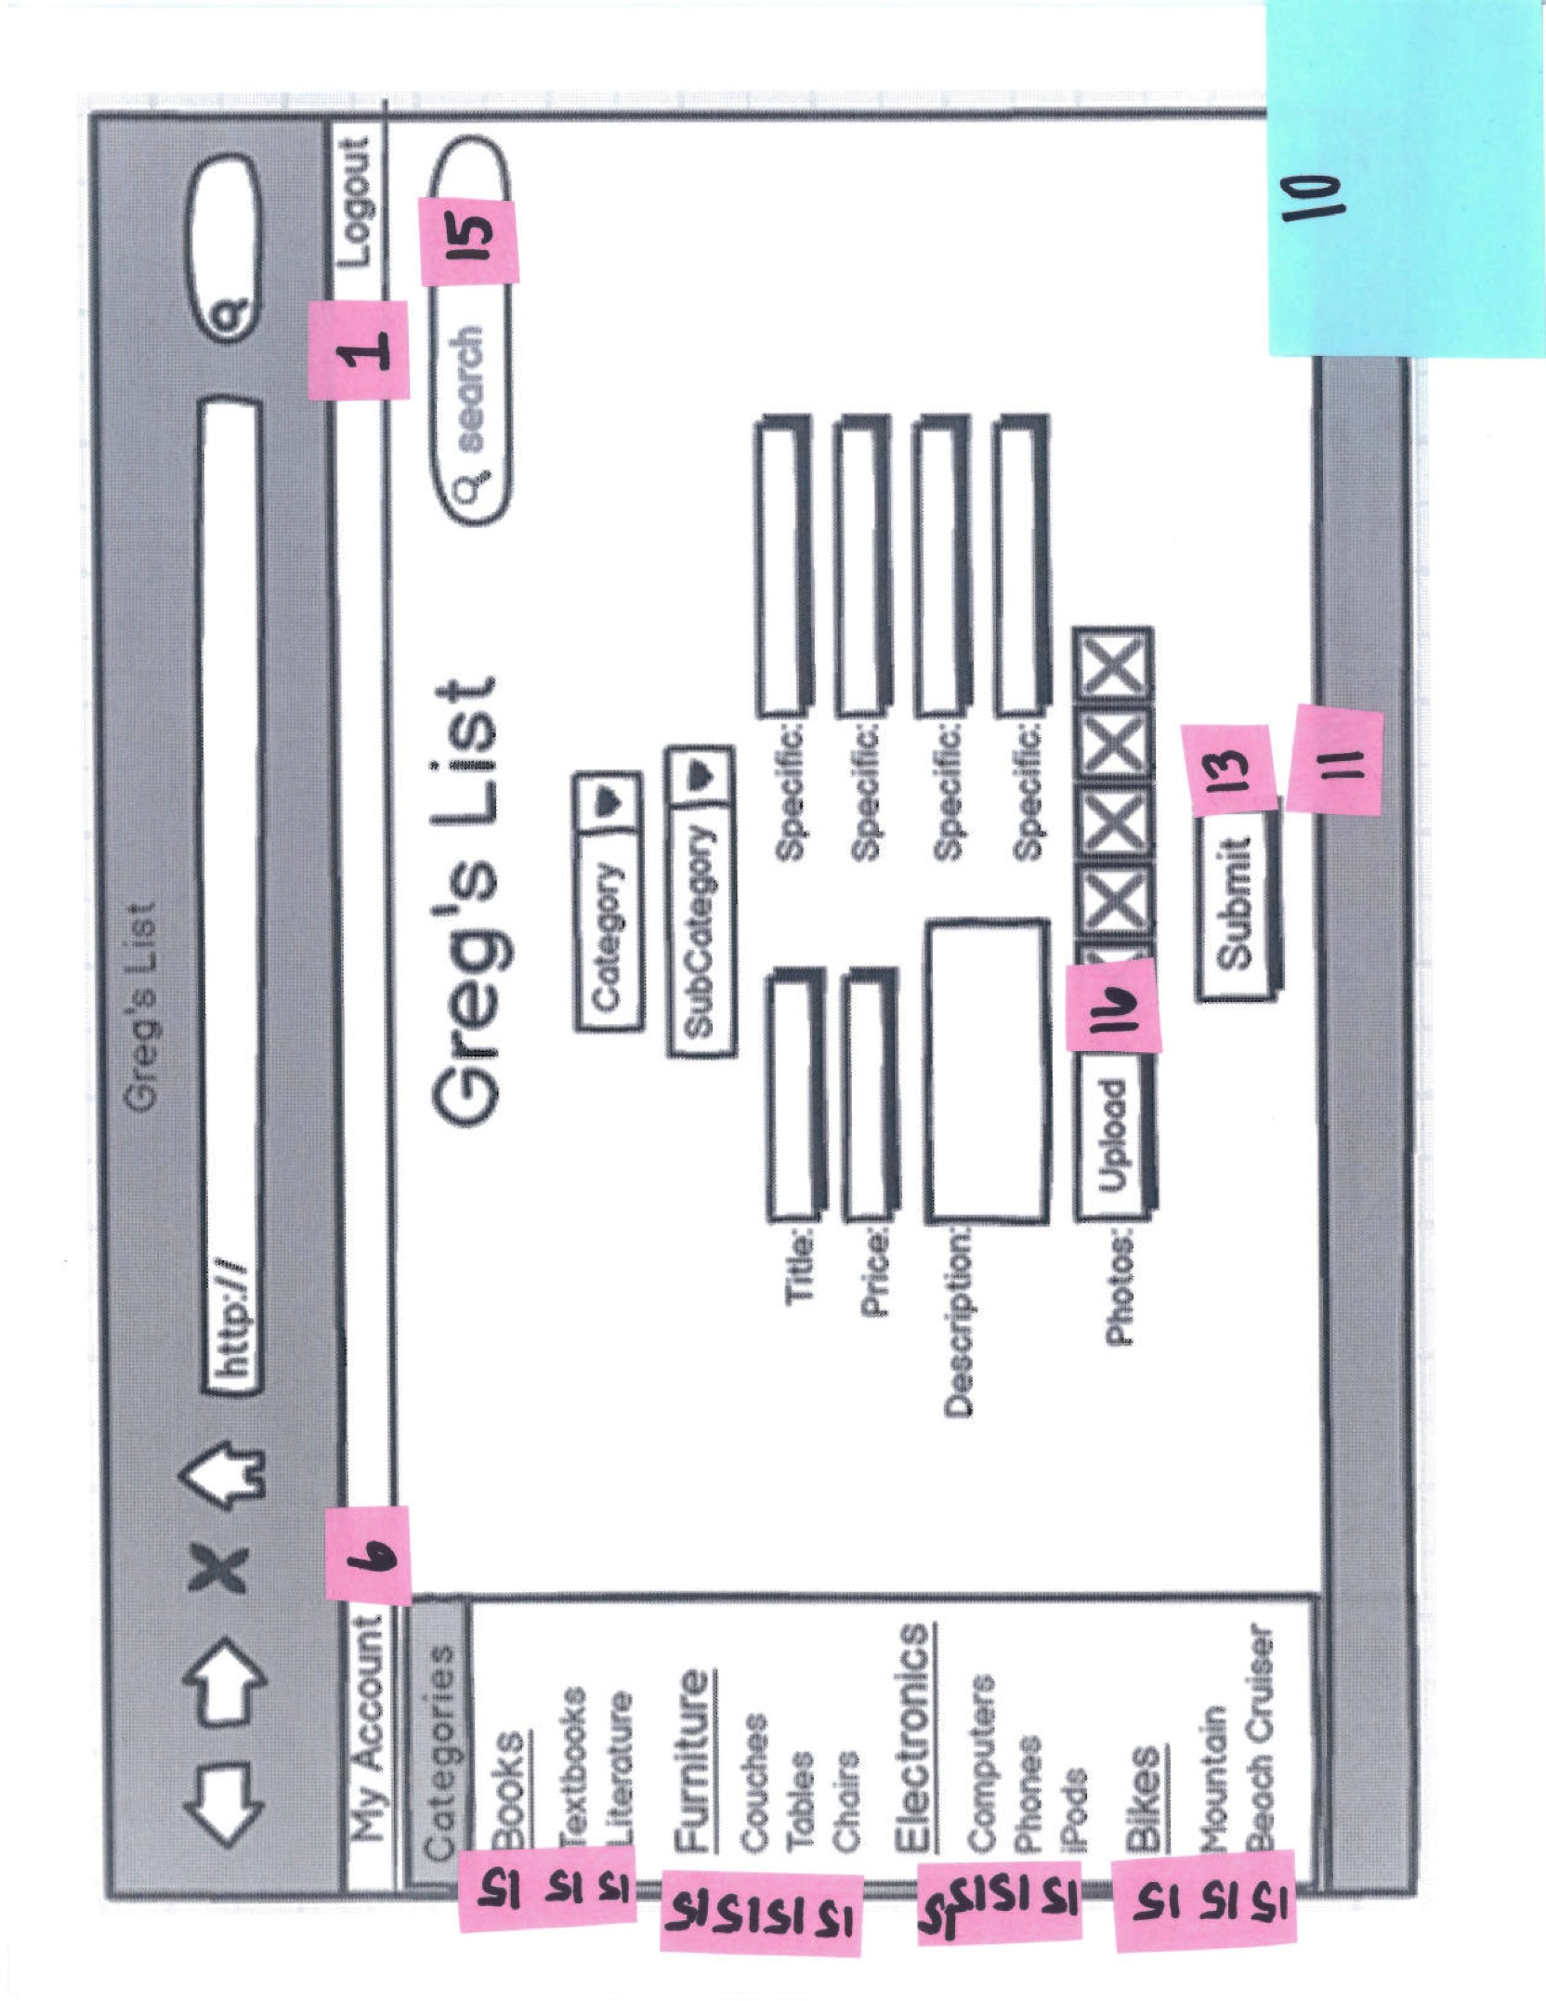 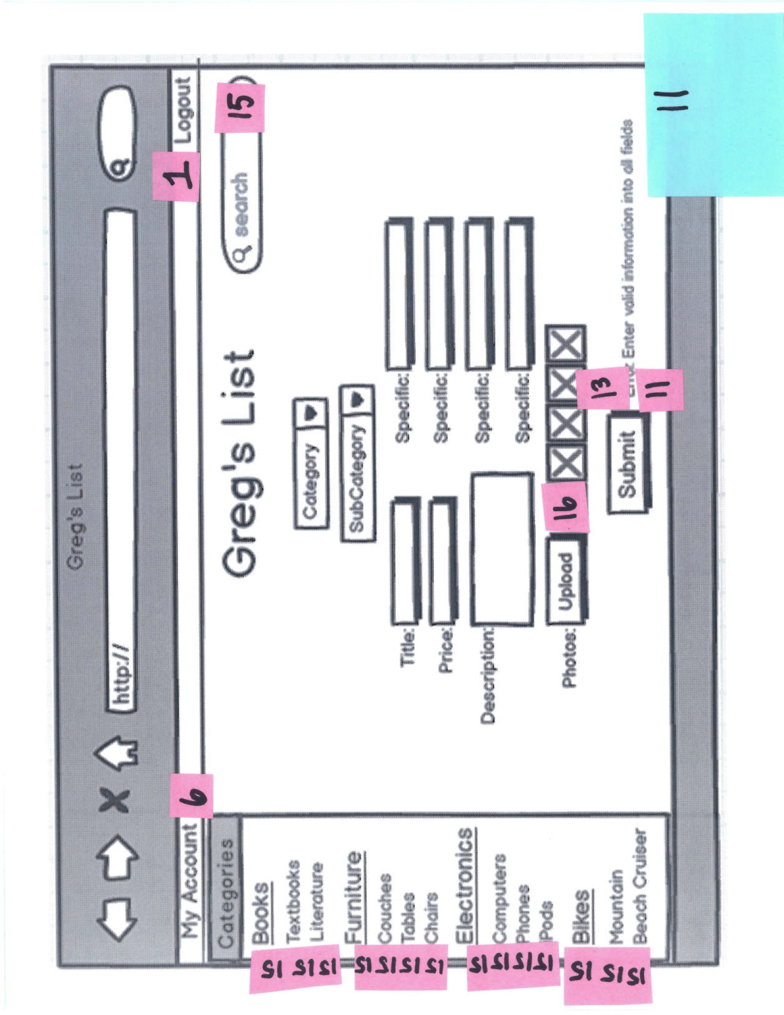 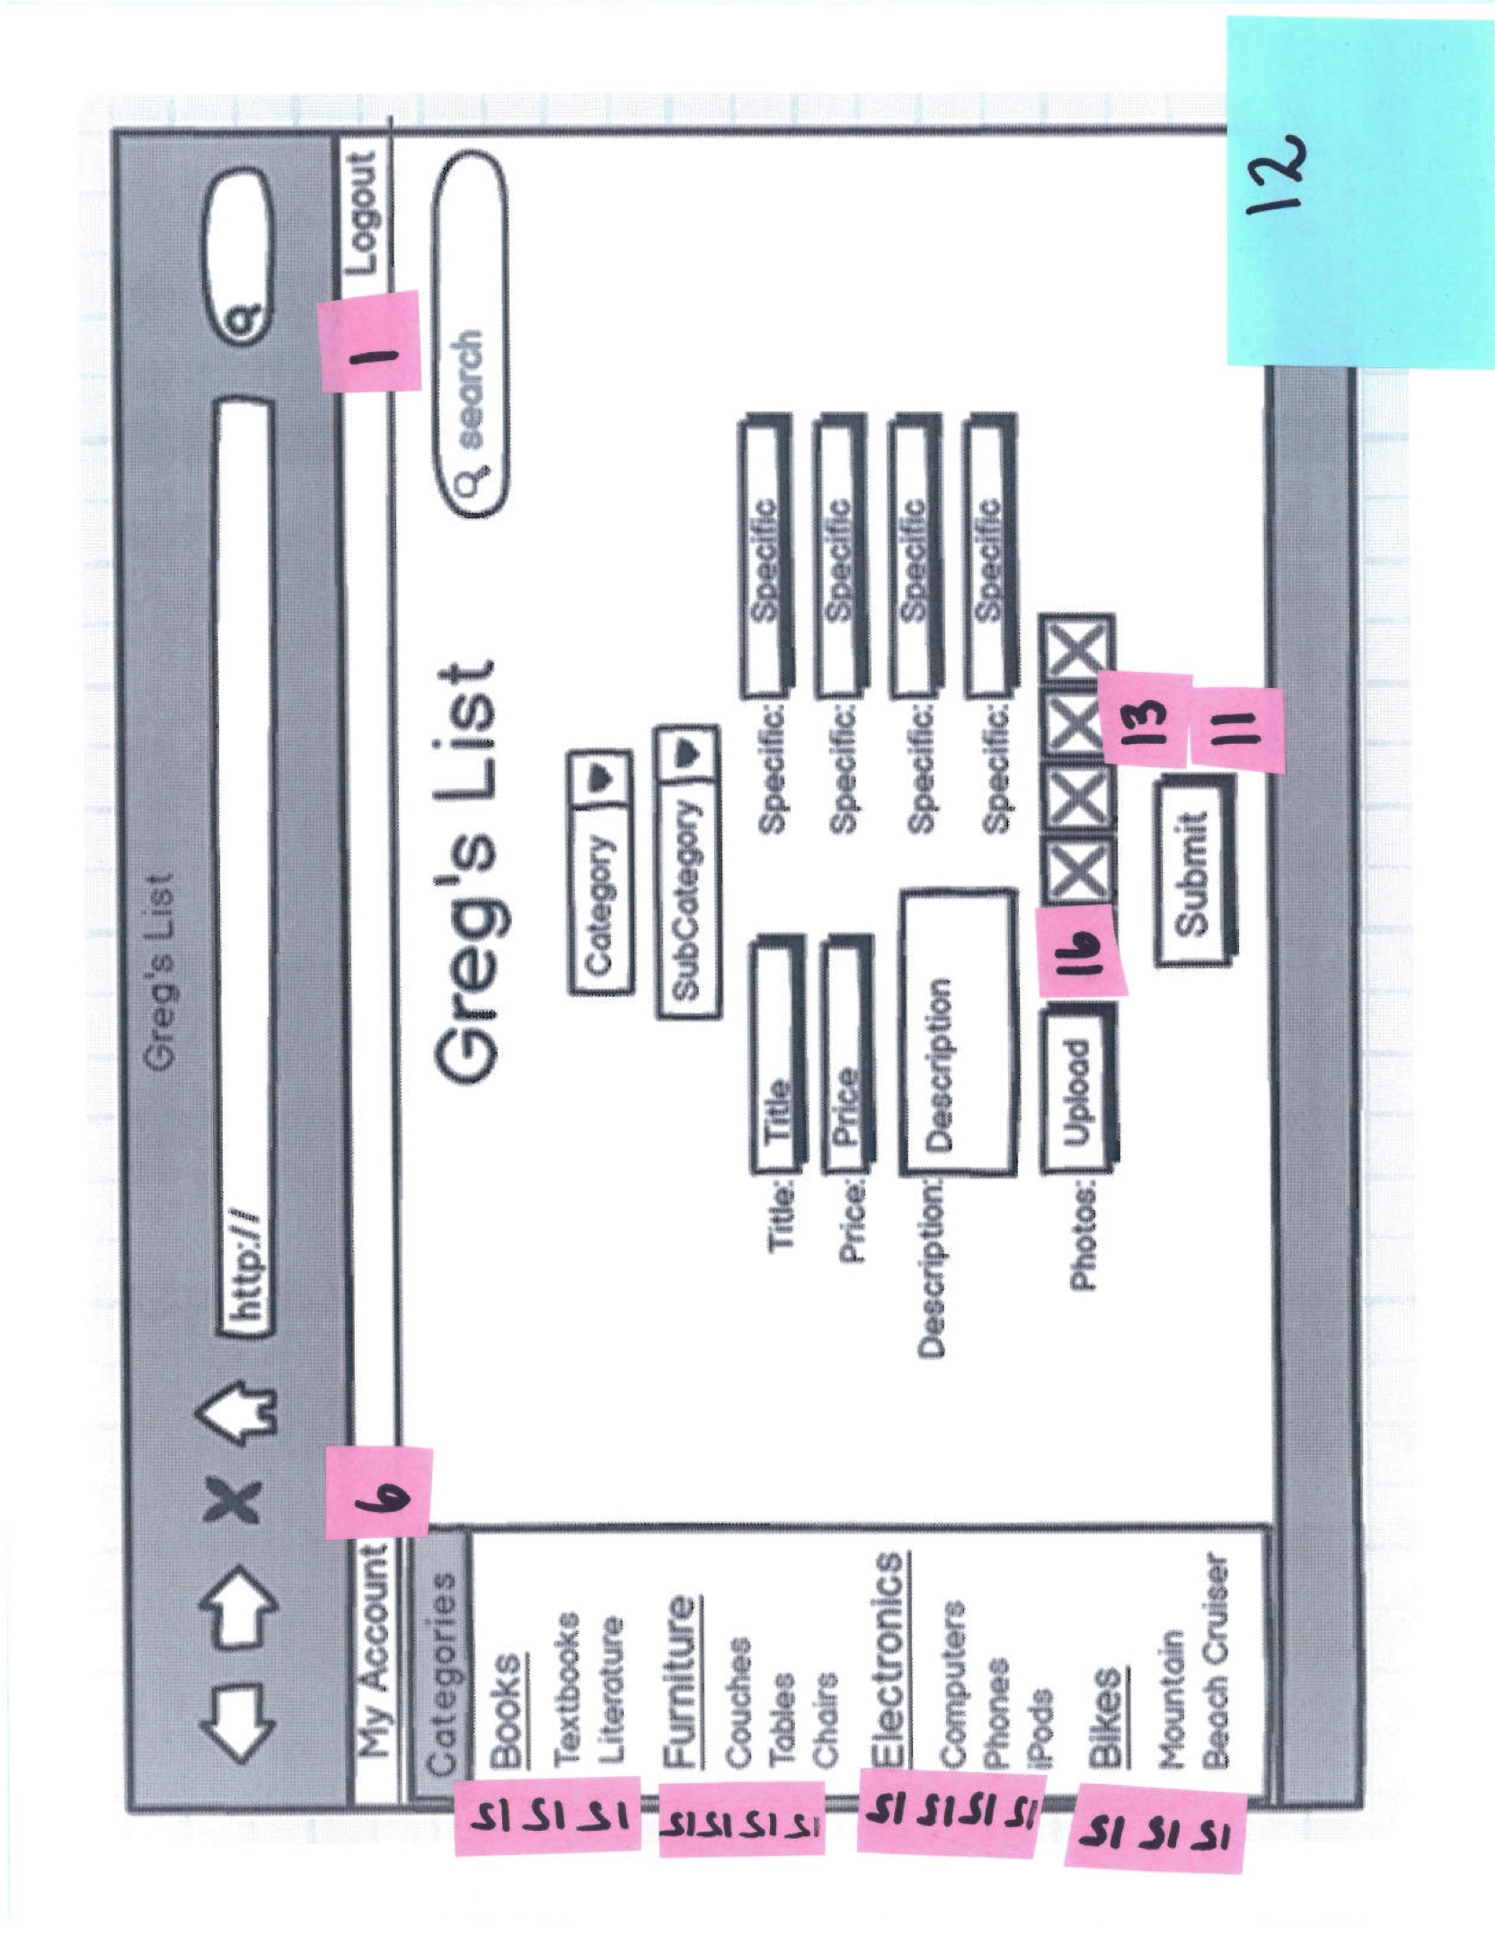 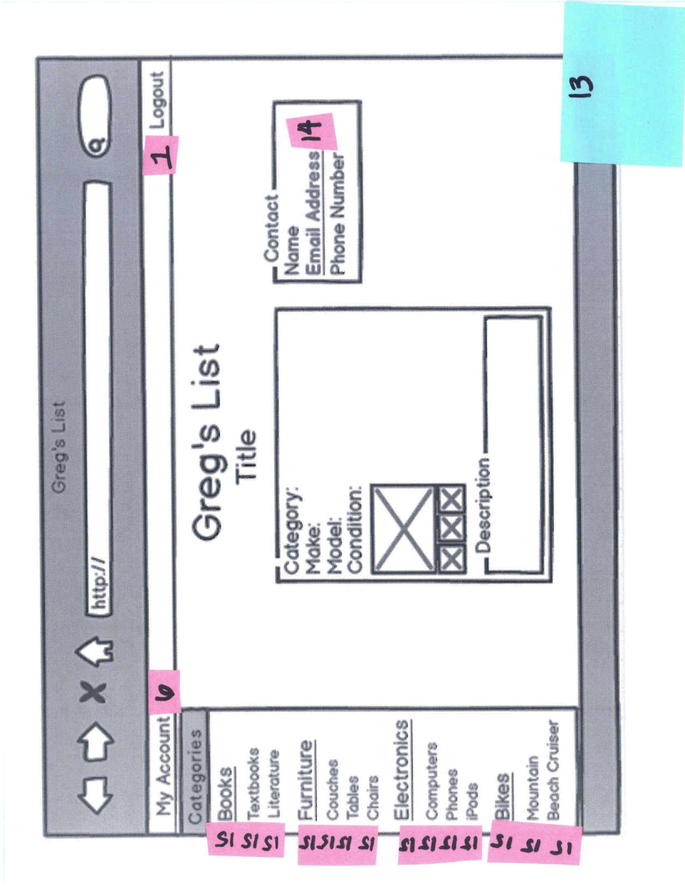

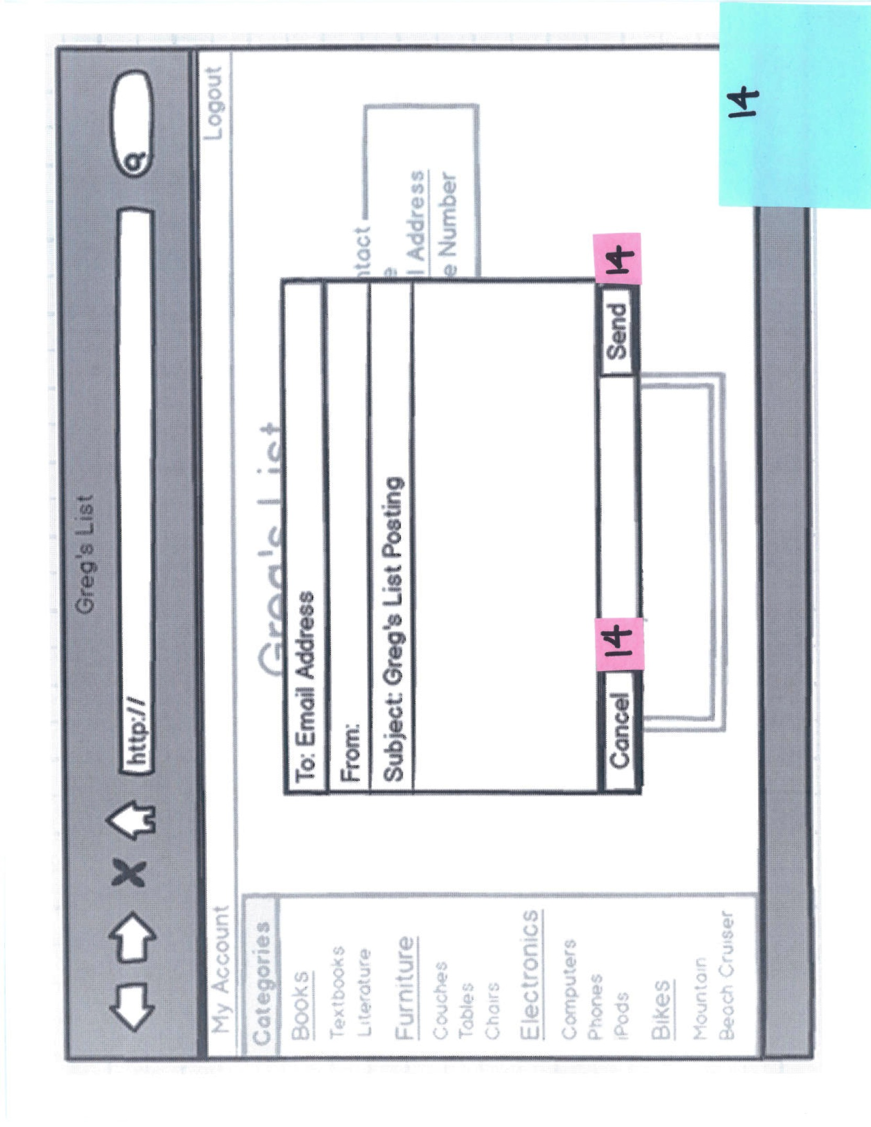

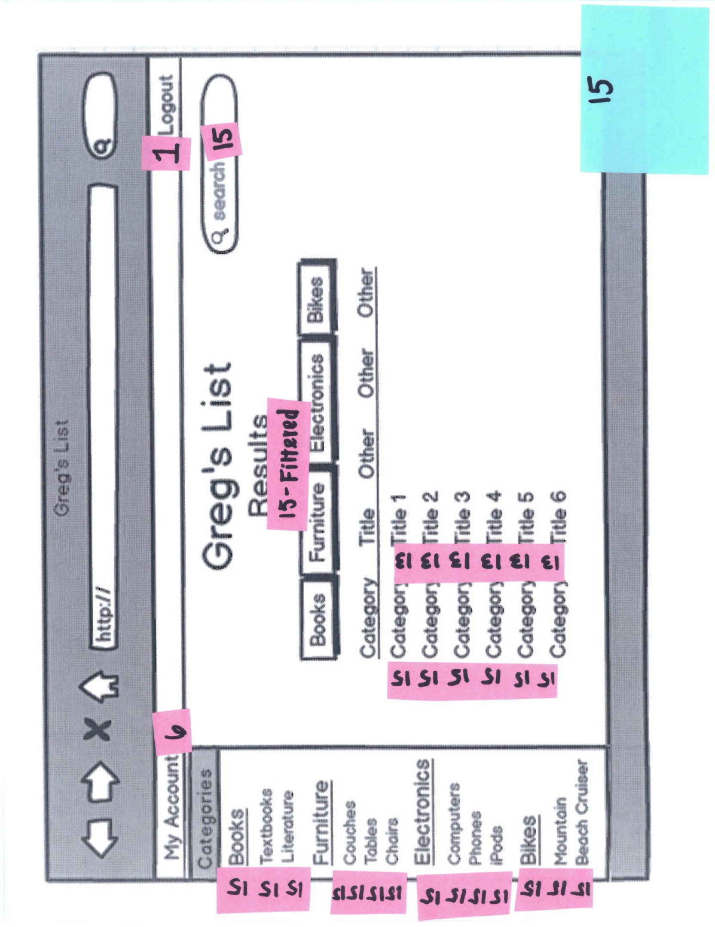

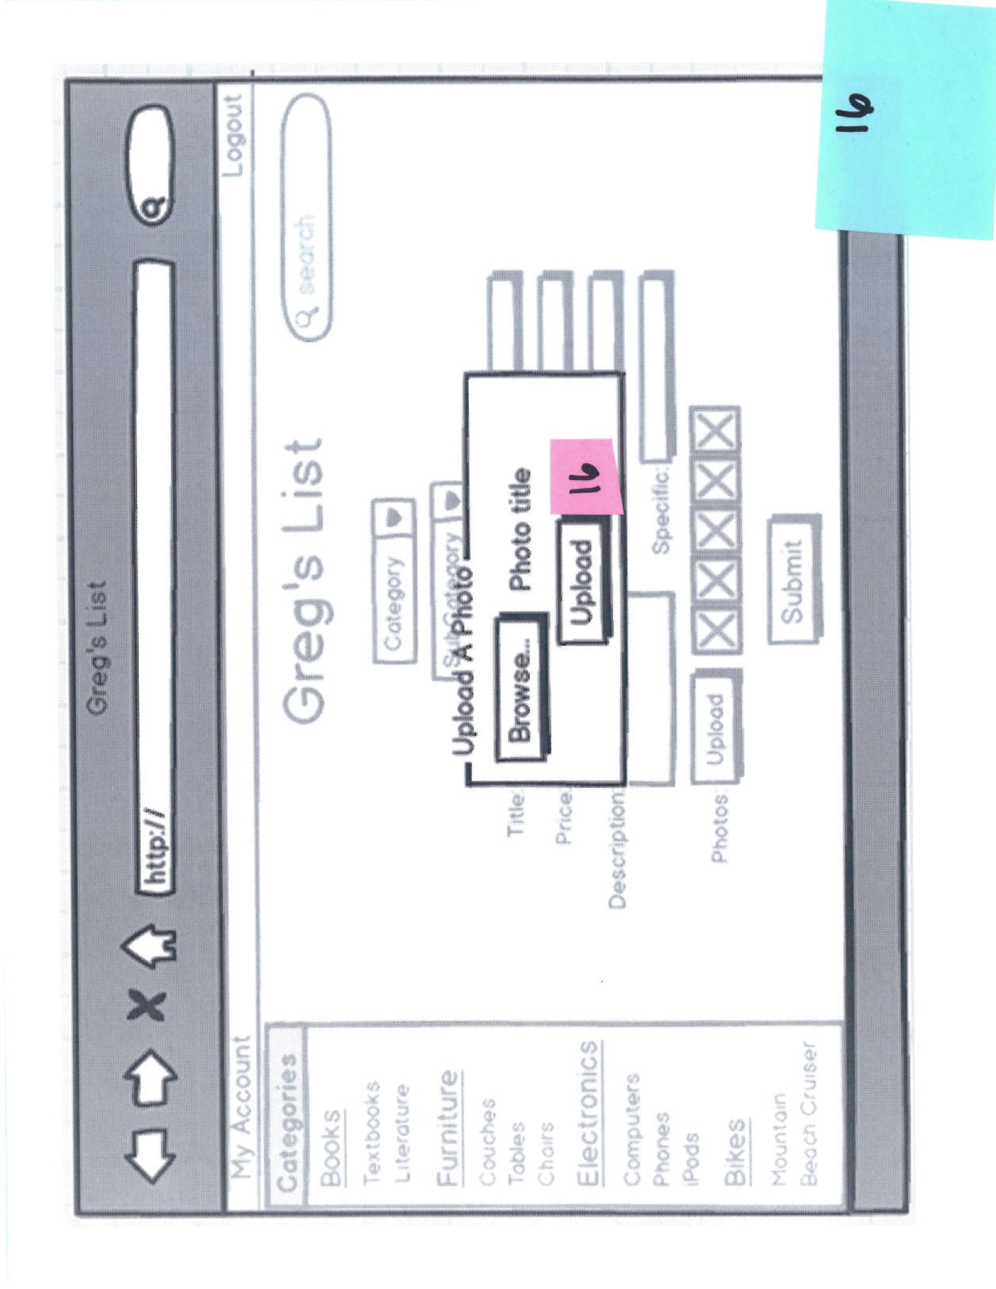

# Usability Report

**General Outcome:** The user was able to proficiently use the website and was able to intuitively

solve problems with only minor or annoying problems.

**Detailed Changes to be Made:**

* Upon failing to correctly fill out a sign up field the website shall place red text next to the incorrect field with a brief error message i.e. “That email address is already registered”
  + Minor Problem
* Place a home button on the top navigation bar
  + Annoying
* Clicking the “Greg’s List” title should be return the user to the home page
  + Annoying
* Remove the “Create Listing” button from the home page and add it to the top navigation bar
  + Annoying
* A listing needs a way to be deleted or marked as sold/closed
  + Missing Functionality
* We have a section on the My Account page that shows watched listings. However, there is no way to add listing to a user’s watched list. Add a button to an individual listing page title “Watched” that will add the listing to a user’s watched listings.
  + Missing Functionality

**Additional User Feedback:**

* On the login page add a screen shot of live listings or create a few sample listing to display so a new user will be able to more quickly understand what Greg’s List is for. This will also serve to make the login page more exciting and inviting.
* Recommended buttons/links for the navigation bar
  + Home
  + Create Listing
  + My Listings
  + My Account
  + Logout
* On the home page remove the four category boxes that display the most recent listings. This is boring. Replace with a picture slide show. The slide show can still show the newest listing in the four categories but display a picture of the item and the price. This will make the home page look more appealing and will catch the users eye. By displaying the price a user might be more inclined to click on the listing if the price is just an incredible deal.
* Look into handling email ourselves. Instead of having an email address link open outlook, which can potentially be time consuming, open a light weight email pop up that the user can compose an email in. By not opening outlook the user will stay on our website and not be distracted by outlook.
* On a search result page reformat the filtering options. They are currently buttons that might confuse a user into thinking that the buttons will take them to a page of all book or electronic listings. Replace them with either a drop down menu label “filter by” or convert the buttons to radio buttons.

**Sarah Lynn Woodruff: Sophomore**

* The home page needs to be centered
  + Annoying
* On the account page the Contact, My Listings and Watched Listings boxes should all  be the same width
  + Annoying
* In general thought the website was rather ugly
  + Cosmetic

**Cooperative Test with Kevin and Nathan: Juniors**

* Add photo listings to home page
  + Cosmetic
* Replace the ipod subcategory with MP3 player
  + Preference
* Add a confirmation pop up for when a listing is removed
  + Missing Functionality
* Form errors should specify a field
  + Annouying
* Change filter buttons into a drop down menu
  + Preference
* Create a drop down for iPhone models
  + Preference
* Set photo upload limit  to 5
  + Minor
* Editing a listing should be handled in a pop up instead of a separate page
  + Preference
* Highlight the current category/subcategory a user in currently browsing in the left hand category navigation bar
  + Annoying
* Filter by date or price
  + Missing Functionality
* Display user’s search query on results page
  + Missing Functionality
* Provide logout verification
  + Missing Functionality
* Enlarge listing pictures on click
  + Missing Functionality

# Task Analysis

**What is the most important feature you would want when buying products?**

Carlos: I want to easily be able to see the price and quality of an item.

Courtney: I want to be able to view pictures of listings I'm interested in.

Ella: I'd like to be able to easily contact the seller.

**What is the most important feature you would want when selling products?**

Carlos: I have no interest in selling products.

Courtney: I'd like to be able to edit my listing after having posted it.

Ella: I'd like to be able to quickly list my items.

**What main feature would you want when searching for products?**

Carlos: I'd like to be able to search all listings

Courtney: The ability to filter my searches down to exactly what I'm looking for

Ella: I'd like to be able to get information about the item without having to click on the full listing

**How would you want to be contacted by interested buyers of your listing?**

Carlos: I would not be selling any products

Courtney: I'd want to get texts on my phone from any interested buyers.

Ella: I would want to be contacted by email because I don't want to put my phone number on the

listing.

**Would you like the ability to watch specific listings for easy later viewing?**

Carlos: No, I probably would not go back and check them later.

Courtney: Yes, I'd like to be able to keep tabs on an item in case the price drops.

Ella: Yes, I'd want to be able to mark items that seem interesting and then view them in detail later.

Based on this information the main functionality of the website will be facilitating fast and easy

searching and selling of products for students and faculty at Southern Methodist University. All of

the product listings will have a simple layout and provide images to allow fast information gathering

about any interesting listings. Ease of contact with the buyer/seller of a specific item will be

provided in the form of a listed email and/or phone number for each listing. The ability to watch

specific listings for later viewing in cases where a user is interested if the price will drop or does

not have the time to view a listing until a later point will also be included.

# Object/Action Analysis and Matrix

WAITING

# Software Lexicon

* **Listing**
  + An advertisement posted by a user that is visible to other users. The Listing contains the details about the item being sold including but not limited to pictures, price and contact information.
* **Title**
  + The description of a listing shown on the search results page
  + Not the description field a user can fill out to give additional information on their listing
* **User**
  + Anyone with a valid smu.edu email address.
* **Seller**
  + Any user who has a listing. A user trying to sell something
* **Buyer**
  + Any user who is browsing the listings regardless of actual purchase
* **Category**
  + Limited to what we define
  + Currently includes: Books, Furniture, Electronics, Bikes and Misc.
* **SubCategory**
  + Included for the Furniture, Electronics and Bikes category
  + Ex Furniture type could be chair, futon or couch
* **Contact info**
  + At the very least must contain the users email address and address
* **Description**
  + An optional part of a listing in which a seller can write anything they want. Intended to describe the quality of the product or any to list any other information the seller deems important
* **Watched Listing**
  + Any listing that a user has flagged or book marked to find later.
  + Watch listings are added to a box on the user’s account page
* **Log in Page**
  + The page a user first encounters when visiting gregs-list.com (tentative url)
* **­Home Page**
  + The page a user is redirected to after logging in